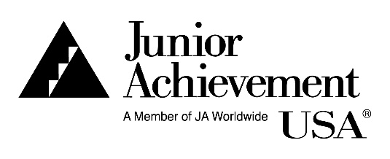

Junior Achievement USA®
One Education Way
Colorado Springs, CO 80906
(719) 540-8000
www.ja.org
JA Volunteer Media Release and Consent

Junior Achievement USA and Junior Achievement of Greater Fairfield County (collectively “JA”) enage with volunteers (“JA Volunteer”) to deliver educational programs in-person and online. JA Volunteers deliver these programs using content provided by JA (“JA Materials”), but may also create content for use with these programs (“Volunteer Created Materials”). In presenting the JA Materials or the Volunteer Created Materials, the Likeness (defined below) of the JA Volunteer may be captured and reproduced. This JA Volunteer Media Release and Consent (the “Agreement”) (1) authorizes JA to use the Likeness of the JA Volunteer, (2) clarifies the ownership of JA Materials and Volunteer Created Materials, and (3) grants JA a license to use the Volunteer Created Materials as described below. For good and valuable consideration, including the opportunity to serve as a JA Volunteer, I agree as follows:

JA Materials
- I understand that JA is the sole and exclusive owner of all right, title, and interest in and to all JA Materials, any media embodying the JA Materials, and any derivatives of the JA Materials. If it is ever determined that I own any rights in the JA Materials contrary to what I have represented herein, I hereby irrevocably assign, transfer and otherwise convey to JA all right, title, and interest in the JA Materials.
Volunteer Created Materials
- I grant JA, a perpetual, non-exclusive, irrevocable, sublicensable and royalty-free right to copy, distribute, publicly display, publicly perform, create derivative works, edit, enhance, publish and use the Volunteer Created Materials in any medium and in any manner throughout the world.
- I represent and warrant that all Volunteer Created Materials furnished by me are free of third-party content or materials, unless I have express written permission from all rightsholders, including the right to license such content to JA hereunder. I confirm that such Volunteer Created Materials do not infringe upon any copyright, trademark, trade dress, rights of privacy or publicity, patent rights or third party contract rights and do not contain libelous or scandalous matter.
My Likeness
- JA may use my name, voice, image, picture, silhouette, and other aspects of my likeness (“Likeness”) in any recording, video, still-image, photograph, or other form of media without restriction, in connection with its use of JA Materials, Volunteer Created Materials, and JA programs, or for any purpose related generally to JA, including commericially and in connection with the creation and use promotional materials, advertising, and publicity.
I will not sue, dispute, challenge, or institute proceedings against JA for using the Volunteer Created Materials or my Likeness and I hereby waive all legal and equitable rights I may have as well as all claims, damages and expenses arising directly or indirectly from the same. I agree to indemnify, defend and hold JA harmless from any and all actions, damages and liabilities (including attorneys’ fees and costs) that may arise by or in connection with a breach of my representations herein. I am under no obligation to sign this Agreement but so voluntarily understanding that this Agreement is binding on, and shall benefit, JA, me and our respective (as applicable) heirs, devisees, legatees, representatives, guardians, conservators, administrators, successors, assigns, agents, transferees and estates.
___________________________________________  Volunteer’s Name (Print)  ___________________________________________  Volunteer’s Signature  Date: ______________________________________ | __________________________________________  Parent/Guardian Name (Print)  ___________________________________________  Parent/Guardian Signature  (Individually and on behalf of Volunteer if Volunteer is Under 18)  Date: ______________________________________

