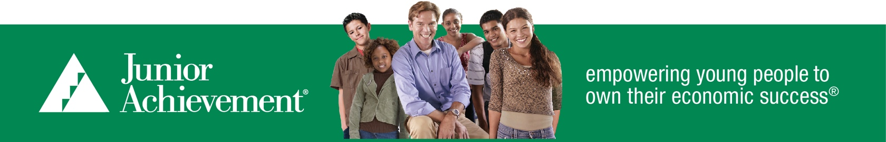

Junior Achievement of
Greater Fairfield County
Volunteer Conduct Standards
Each year Junior Achievement staff shall convey these standards in writing to all volunteers prior to their first visit to the classroom. Staff shall review these standards verbally, as well, with volunteers teaching for the first time.

Junior Achievement (JA) serves youth. JA volunteers teach valuable lessons in their program delivery and especially in their conduct with students. Adult misconduct with or in the presence of youth carries serious consequences. Because Junior Achievement cares that its volunteers have healthy, appropriate relationships with the youth they serve, it has established the following standards.
- Young people look to adults for examples of appropriate behavior. JA volunteers must use appropriate language and model honorable behavior, such as respect, integrity, honesty, and excellence. Profanity or sexualized language or jokes are inappropriate when working with students, regardless whether it occurs face-to-face, over the Internet, or by any other means. JA strictly forbids violating any state law regarding interactions with youth; for example, providing them alcohol or legal or illegal drugs, or coaxing them into illicit relationships over the Internet or otherwise.

- Volunteers should avoid all contact with students beyond a business handshake.

- Interactions with students must both be appropriate and appear appropriate. It is expected that volunteers’ interactions with students are at all times appropriate and professional, and are strictly related to the role of business mentor. It is unacceptable to seek or engage in one-to-one meetings with students at any time.

- Volunteers are responsible for the quality of interactions. Students often find it difficult to state discomfort or objections. Volunteers must be especially sensitive to physical and verbal cues that youth provide.

- Volunteers will be presenting, facilitating and discussing various programs, content and ideas with students that are likely owned by JA, its licensors or the students. A primary purpose of the JA programs is to encourage creativity by the students. By working with JA and the students, Volunteer agrees that they do not obtain any intellectual property rights therein, will not seek ownership in or to contest those intellectual property rights, and will not attempt to secure trademark, patent or other intellectual property rights or registrations therein without prior written consent from Junior Achievement USA.
The aforementioned standards do not represent a comprehensive list. Other actions not included could result in suspension or dismissal as a volunteer. JA volunteers also must read and comply with JA’s Digital Media Policy.

Junior Achievement takes all complaints of misconduct seriously. Credible allegations of misconduct will be promptly reported to the appropriate authorities. During any such investigation, the JA volunteer will not perform services as a JA volunteer. If an investigation determines misconduct occurred, it will result in the immediate and permanent dismissal as a JA volunteer.

Any JA staff member or volunteer who reasonably suspects misconduct must report these suspicions immediately to the appropriate JA staff person within their JA Area.

- - - - - - - - - - - - - - - - - - - - - - - - - - - - - - - - - - - - - - - - - - - - - - - - - - - Sign and return - - - - - - - - - - - - - - - - - - - - - - - - - - - - - - - - - - - - - - - - - - - - - - - - - - -

I have received copies of Junior Achievement's Volunteer Conduct Standards and Digital Media Policy and have read, understand, and will abide by these standards. Please return this form to your JA Area.

By signing this, I hereby certify that I have never been charged with violence, or any type of charge involving a child or young person, or, if I have, that I have fully disclosed in writing the facts regarding such a charge to my local JA Area.

Signature: Date:

Name:
(please print)

